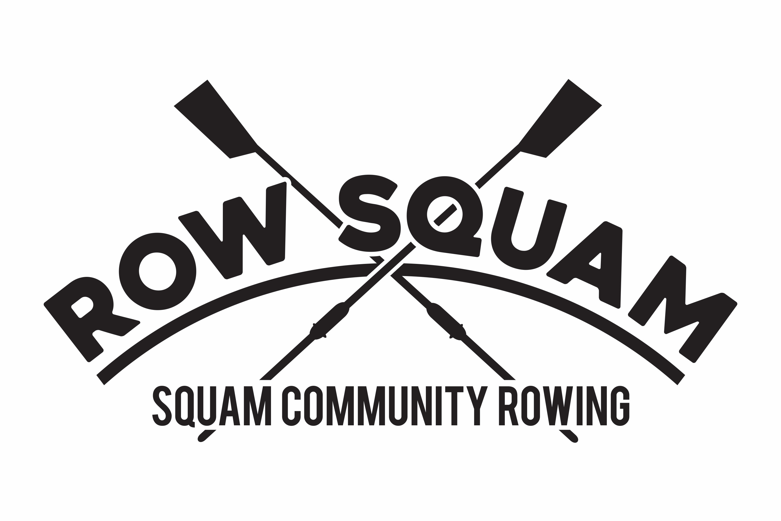 Membership Form

Member Information

Name:_________________________________________________________________

Address:___________________________________________________________________

Email address: ____________________________ Best phone #: ___________________

Date of birth: _____________ Gender: ______ Height: ________ Weight: __________

Emergency contact: _____________________________________

Emergency Contact Phone: ______________________________

Other Rowing Club affiliations: ___________________________________________
US Rowing #: ____________________ expires:________________

Rowing experience: Beginner_____ Intermediate ____ Advanced _____ Yrs ______

I attest that I can swim Y / N Tread water for 5 min Y / N Have own equip Y / N

Annual dues to be paid by June 1st $250.00 (22yrs and older)
Annual dues to be paid by June 1st $125.00 (student/young adult 18 yr to 21yr)

Required to join Squam Lakes Association (squamlakes.org) Joined? Y / N
Required to join USRowing (USRowing.org) Joined? Y / N
Current SCR Waiver Signed? Y / N

Please make check payable to: Squam Community Rowing, and present to any SCR Board Member.
Membership Fee Enclosed $_____________________

Questions? Contact the club email

squamcommunityrowing@gmail.com

Please visit our website www.squamcommunityrowing.com
Join us on Facebook at Squam Community Rowing
Squam Community Rowing is a non-profit 501C3 established in 2013

